ELEVATOR BUFFERS

MLB SERIES INS TALL ATION GUIDE
MLB 13-32

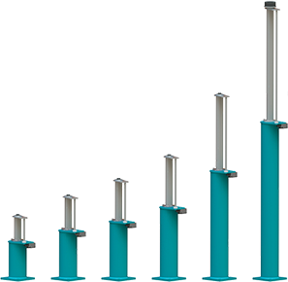
INSTALLATION GUIDE
ENGLISH

MLB 13-32 BUFFERS : INSTALLATION INFORMATION
SCOPE OF DELIVERY

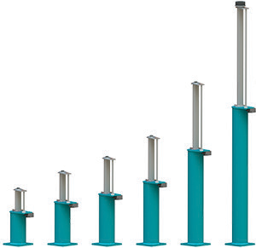
Oleo buffers are supplied with a standard finish suitable for dry conditions (finished Oleo Green primer). The standard finish is not suitable for wet, corrosive conditions.

Environmental temperature acceptable conditions -15°C to 70°C.

Oleo MLB buffers can be supplied pre-filled with oil, or without oil.
Check the buffer to confirm it is pre-filled or without oil.
Should there be any discrepancies contact Oleo International before proceeding.
INDICATION OF USE
! WARNING
The Oleo MLB elevator buffer is supplied containing compressed gas; the plunger is held in the fully compressed condition during transportation by means of a bolt, this should not be removed until the buffer is in its final installed position.

When handling MLB buffers ensure your regional health and safety laws are adhered to.
HANDLING

Figure 1

! WARNING
DO NOT lift buffer with the striker shown in Figure 1. Avoid contact as this may cause damage.

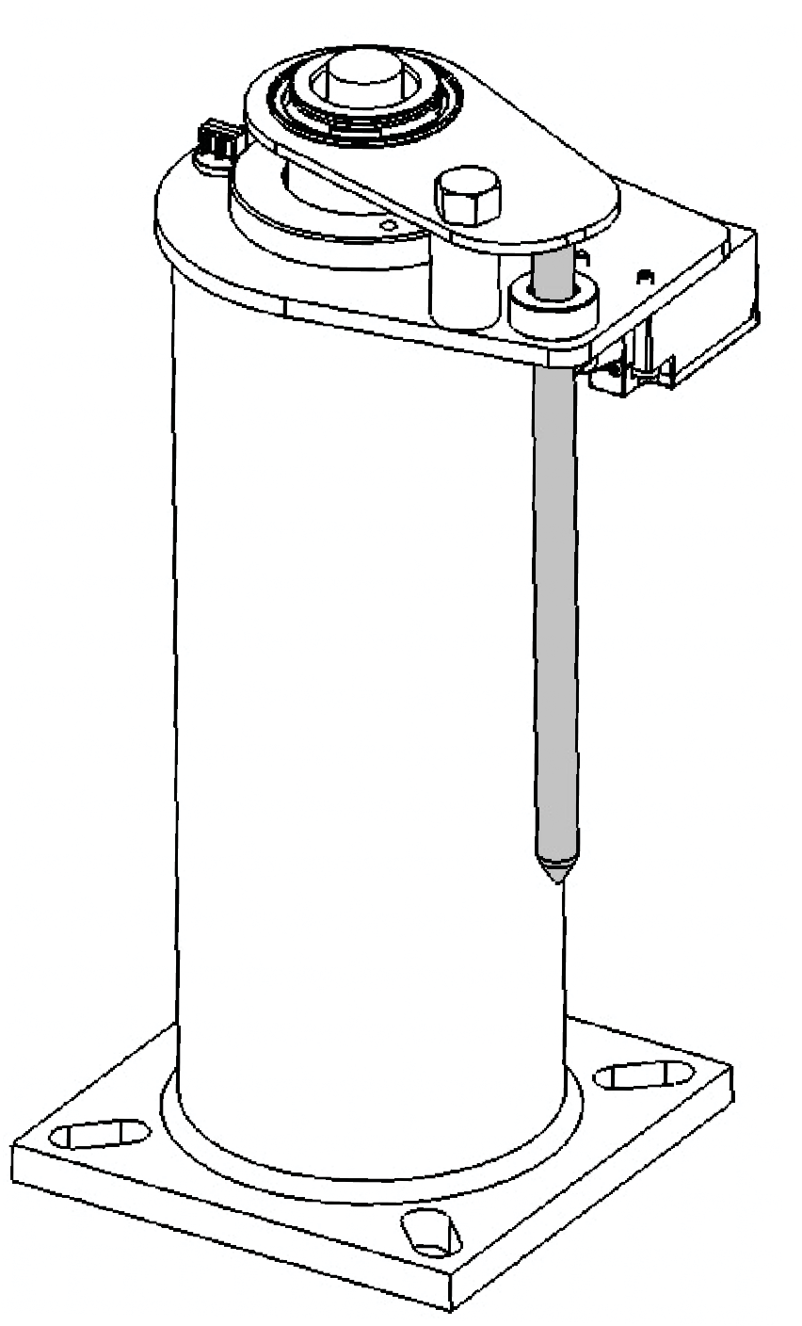Always confirm the weight of the buffer to be lifted and ensure that a suitable lifting method is used.

MLB 13-32 Range
4 BUFFER WEIGHTS

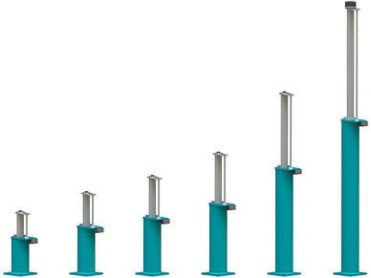

Buffer Model  Without Oil Kg | MLB 13  9.810 | MLB 16  11.15 | MLB 18  12.67 | MLB 20  15.02 | MLB 25  21.05 | MLB 32  29.72
Lbs | 21.63 | 24.58 | 27.93 | 33.11 | 46.41 | 65.52
When Filled with  Kg | Oil  10.10 | 12.39 | 14.01 | 16.94 | 23.97 | 34.29
Lbs | 23.61 | 27.32 | 30.89 | 37.34 | 52.85 | 75.59

Ensure the buffer has been secured into its installation position.
5 BUFFER INSTALLATION PROCEDURE
Oleo recommends a bolt size M12 for fixing and all four fixing positions are used. Ensure this area at the base of the buffer, shown in Figure 2 is supported.

Figure 2
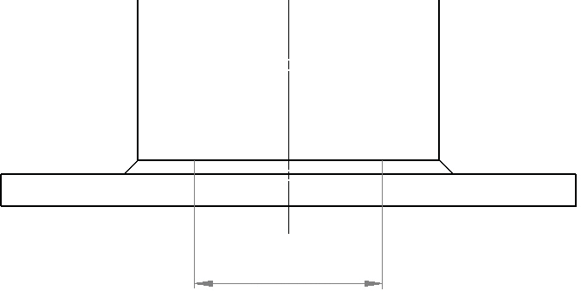
69.85mm
2.750”

At this point the buffer is still compressed in its transportation state, now the buffer can be released by removing the transportation bolt. The following is the recommended removal procedure.
For a controlled release, lower the elevator car (or equivalent) onto the buffer. This mass must be at least equivalent to the minimum mass of the specified buffer.
Minimum mass of the buffer show in the table below:

Buffer Model | MLB 13 | MLB 16 | MLB 18 | MLB 20 | MLB 25 | MLB 32
Min. Mass
Kg  Lbs | 450  992 | 450  992 | 450  992 | 450  992 | 450  992 | 450  992

Figure 3
5 BUFFER INSTALLATION PROCEDURE (Continued)
DANGER
Now to release the plunger.
DO NOT stand over the plunger when releasing.

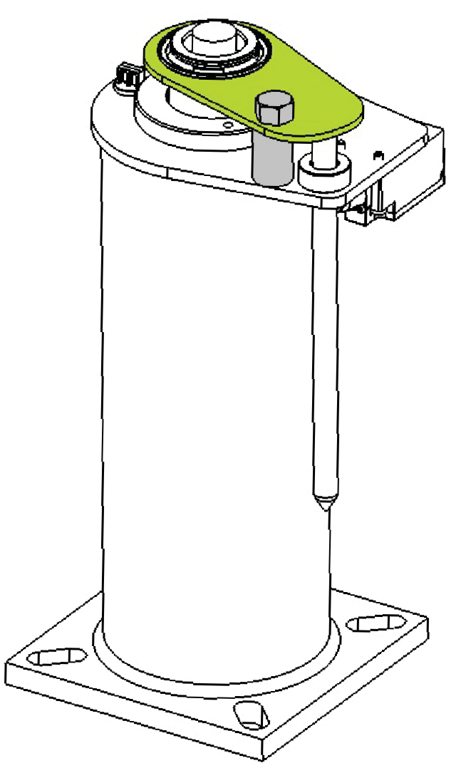To release the plunger, undo the transportation bolt. (GREY in Figure 3).
Discard the transportation bolt and spacer (GREY in Figure 3).
If used, remove the elevator car (or equivalent) and this will control the recoil of the buffer.
After periods of being held in the compressed state during transportation and storage, the plunger may require assistance to initially extend. This should be done using rubber dead blow mallet to tap the underside of the buffer top plate (GREEN in Figure 3) at 90 degree intervals until the plunger extends.
Once fully extended and stroked the buffer will perform as designed.
Buffers are to be fitted vertically parallel to guide rail +/- 5mm.
Do you have a pre-filled buffer? No - Please continue to Section 6.
Yes - Go to OIL FILLING OPTIONS Section 8.

The oil must confirm to the specification on the buffer data plate – ISOVG68: SG.88/90 at 15°C : hydraulic.
6 OIL SPECIFICATION
Pour Point: 18°C or lower. Viscosity index: 75 or higher
CAUTION
Take care when handling the oils.
Observe the oil manufacturers recommendations.

Figure 4

The oil volume guide can be found in table below:
Max
Min
5.19
1.37
3.32
0.88
2.18
0.58
1.74
0.46
1.41
0.37
1.02
0.27
Kg
Lbs
il Volume
Approximate O
MLB 32
MLB 25
MLB 20
MLB 18
MLB 16
MLB 13
Buffer Model

MINIMUM & MAXIMUM
The oil level needs to be between the Minimum and Maximum marks indicated on the dipstick as shown in Figure 4.

7 OIL FILLING PROCEDURE

- 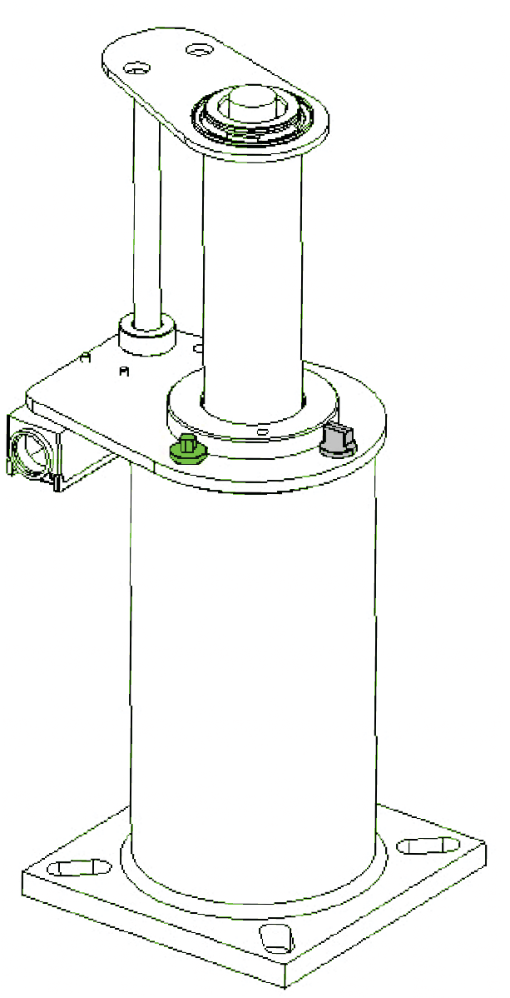Unscrew the airscrew, remove from the buffer and keep safe. (GREEN in Figure 5).
Figure 5
NOTICE
The buffer must be vertical and fully extended before filling with oil.
CAUTION
Take care when handling the oils. Observe the oil manufacturers recommendations.
- Unscrew the dipstick, remove from the buffer and keep safe. (GREY in Figure 5).
- Gradually fill the buffer with oil until the oil level is visible between the minimum and maximum levels on the dipstick (indicated on Figure 4).
- Allow the buffer to stand for a minimum of 30 minutes.
- Re-insert the dipstick DO NOT screw down.
- Remove dipstick and inspect level. The oil level needs to be between the minimum and maximum marks indicated on the dipstick as shown in Figure 4.
- Once oil level is correct replace airscrew and securely fasten.
- Once oil level is correct replace dipstick and securely fasten.

The oil must be within the correct operating range for the buffer to perform correctly. If further oil is required after checking repeat steps 1-8.
WARNING
DO NOT overfill past the maximum dipstick mark.
If this occurs, then oil must be removed from the buffer.

WARNING
DO NOT overfill past the maximum dipstick mark.

The oil level must be correct and needs to be checked using the following procedure:
8 OIL FILLED OPTIONS
9 OIL CHECKING PROCEDURE
Figure 5

- Unscrew the dipstick and remove from the GREY on Figure 5).
- Wipe dipstick clean.
- Re-insert the dipstick DO NOT screw down.
- Remove dipstick and inspect level. The oil level needs to be between the maximum and minimum marks indicated on the dipstick as shown in Figure 4.
- Once oil level is correct replace dipstick and securely fasten.

The oil must be within the correct operating range for
If further oil is required after checking refer to Oil Filling Procedure Section 7.

NOTICE
If the buffer has not returned to the fully extended position (determined by measuring overall height) contact Oleo International.

Oleo recommends the final 7 step process is followed prior to commissioning:
10 FINAL COMMISSIONING
- Ensure oil level is correct.
- Ensure striker is vertically aligned to +0.5 mm.
- Complete electrical connections to the limit switch.
WARNING
As a safety critical component, buffers should not be installed without a switch.

- Compress the buffer at slow speed across the full working stroke then allow to recoil. 5 Allow the oil to settle for 30 minutes then recheck oil level – see Section 9.
- Finally, impact the buffer at the full rated speed of the elevator.
- Complete final checks of oil level and the buffer is at correct working height.
NOTICE
CHECK: The maximum overall height against table below MLB 13-25 +0/-8.8mm and MLB 32 +0/-8.2mm of the figure stated.

h
1.7305
68.130
1.1643
45.839
0.7823
30.799
0.6343
24.972
0.5323
20.957
0.4103
16.154
m
in
t
Extended Heig
MLB 32
MLB 25
MLB 20
MLB 18
MLB 16
MLB 13
Buffer Model

Oleo recommends the following be carried out every 12 months from installation:
11 MAINTENANCE

1 Clean away debris and dirt from around the plunger and switch. 2 Check the oil level is correct.
- Compress the buffer across its full working stroke.
- After the compression, ensure the buffer has returned to its correct working height and visually check for any damage. See correct working height in table in Section 10.

Ensure regional jurisdictions and laws for maintenance are adhered to.

OLEO INTERNATIONAL
Grovelands Longford Road Exhall Coventry
United Kingdom CV7 9NE
E sales@oleo.co.uk
T +44 (0)24 7664 5555
F +44 (0)24 7664 5900
W oleo.co.uk
OLEO BUFFERS SHANGHAI COMPANY LTD
Plant A15 Xinfei Garden No.3802 Shengang Road Songjiang
Shanghai 201612 China
E sales@oleo.cn
T +86 21 6776 0688
F +86 21 6776 0689
W oleo.cn
EUROPE CANADA/USA CHINA KOREA

RUSSIA

GB7588

ASME

0086

This Installation Guide can be found in the following languages;
Français French
Brasileiro Brazilian
Deutsche German
Italiano Italian
Español Spanish
Pусский
Russian
Porigiese Portuguese
한국어
Korean
中文
Chinese
日本語
Japanese

ALTERNATIVE LANGUAGE INSTALLATION INSTRUCTIONS
Please visit:
https://www.oleo.co.uk/downloads/elevator-installation-booklets

9-35703-1 Issue 2 July 2018

Oleo International is a division of T.A. Savery and Co Limited, whose ultimate parent is Brigam Limited. T.A. Savery and Co Limited is a company incorporated in England and Wales under company number 00272170 and whose registered office is at Grovelands, Longford Road, Exhall, Coventry, CV7 9NE, UK.

